# CO2 Meeting 19/06/2017

## Agenda:

estimated duration:~ 2h, 30min

1. 5’: Opening the Meeting and presenting the items of the Agenda that are going to be discussed.
2. 30’: Quick round of the table. Presentation of what has been done since the last meeting. This can be presented by the hosts, while the others start eating.
3. Subjects to be discussed:

* 30’: **Code freezing.** The code is still not freezed. According to the schedule, it should be freezed TODAY.
* 20’: **Rounding bag values assessment.** What are the latest updated of this issue. Results on stability and accuracy. Which is the current best option. The assessment is going to stop?
* 10’: **Petten massive simulations.** Check the availability and the functionality of the cluster. Discussion on the CO2MPAS model that should be installed (depending to the rounding assessment) , Python version must change, Python libraries should be the same with the *AIO 1.6.0.dev4*, or latest that will be used in the next release.
* 10’: **DICE requests Update.** Right now we have 11 recognized as designated users. 2 of them did not send the request for the electronic key, as described in the instructions. All of them have received the first mail - *CO2MPAS Acceptance.* There are requests for personal help for the DICE. One request for Electronic key from KBA.
* 15’: **Official use of DICE.**
* 25’: **Discussion on the ways we will provide the Key.** Presentation of the alternative options. Pros - Cons. Kostis already produced some instructions for producing the key by their own. As discussed, this may be the best solution.
* 10’: **DICE GUI.** When is it going to be ready. Will it be included in the upcoming release?
* 10’: **Discussion on the new priorities and make the schedule again** (bottom of the document).
* 10’: **Holidays schedule revision**.

4. TBD: Presentations/ Talks:

* Vincenzo: Fuzzy implementation in CO2MPAS and how it works.
* Alessandro:
* Biagio:
* Giorgos:

5. 10’: Closure of the meeting, schedule the next one and the hosts.

Round Table:

* Dimitris:
  + E-mails in CO2MPAS and VECTO mostly for the DICE.
  + Validations of the CO2MPAS model
  + Report on the changes in the Real cars.
  + Preparation of Panda, A1, Golf for inserting them in the batches to run.
* Alessandro:
  + PHEV Paper on scedule for Conference in Capri.
  + ECO CHAMPS report review.
  + HDV engine model with Nikiforos.
  + Fuel consumption mapping activity for HDV.
  + Meeting in Torino with Claudio, a former trainee, for the Hybrid model that he implemented.
  + 3 days course in Politechnico di Torino: Sustainable transport systems.
* Iker:
  + Meeting with Nikiforos for running VECTO massive simulations. Current state: it does not run directly on Linux.
  + Meeting with Stefanos. Updates on what has been already done. Github repository for HDF Databases.
* Jelica:
  + WLTP Second Act. Participation in the transparency task force group. The objective is to have the input data (RLs, Gear Shift etc) to repeat the TA tests for every individual car.
  + Correction of cycle flexibilities. Ways to detect the extreme driving patterns and apply correction.
  + Fiat 500X fuel consumption distribution. 8 drivers participated until now and 20.000 km were driven. Big data, ways to open and manipuate them.
* Vins:
  + WLTP bag values rounding assessment.
  + Different implementations of the CO2MPAS code in order to find the best combination to improve the stability and the accuracy.
  + Fuzzy implementation in the code.
  + U-SAVEwih Lorentzo.
* Giorgos:
  + CO2MPAS validations.
  + WLTP bag values rounding assessment.
  + Data from VOLVO for HDV.
  + PHEV Paper with Alessandro.
  + Help on Michalis and Kostas.
* Kostis:
  + WLTP bag values rounding assessment.
  + Major change to the cygwin. Needs testing in the new AIO.
  + DICE requests for assistance
* Michalis - Kostas:
  + Accepted abstact in the AMAA 2017 conference. Waiting for response of the full submitted paper.\
  + C-ART workshop in Brussels. Very good feedback.
  + Working on individual tranjectories in AIMSUN in order to calculate the energy and fuel consumption.
  + Not realsistic models of AIMSUN for decceleration. Working on this.
  + Running simulations for SERPA. There is lack on computational resources.
* Biagio:
  + WLTP second Act.
  + Missions.
* Victor:
  + RDE
  + Hybrid Segment C for market surveillance/RDE, any particular petition?
  + CO2MPAS
  + Spanish Embassador tour in VELA

Last meeting’s schedule consering CO2MPAS:

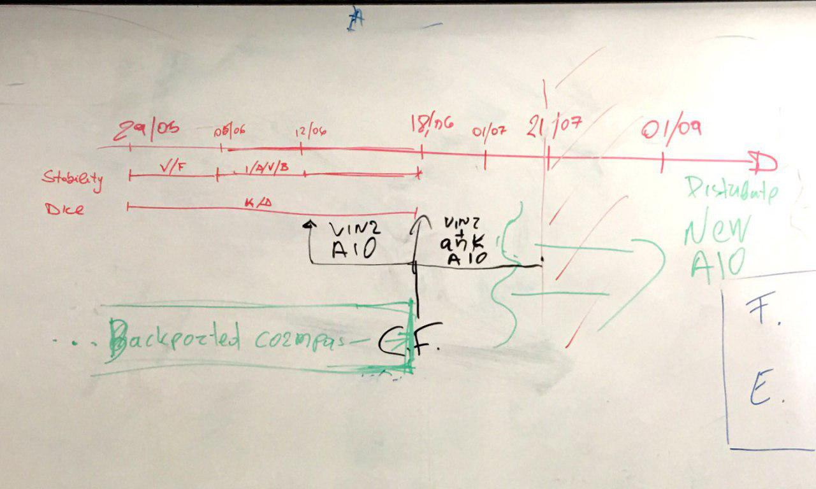

## 

## 

## Conclusions and Action Items:

**Working agenda for Summer release**

|  |  |  |  |
| --- | --- | --- | --- |
| **Task** | **Due date** | **People responsible** | **Status** |
| List python version and libraries that will be included in the AIO | 20/06/2017 | Kostis / Vincenzo | OK |
| Set the proper environment in PETTEN cluster to run CO2MPAS | 21/06/2017 | Iker | OK |
| Identify the variables to be tested in the CO2MPAS fine tunning and generate the simulation plan | 21/06/2017 | Georgios, Biaggio | OK |
| Launch the simulations in PETTEN cluster | 22/06/2017 | Dimitris, Iker | OK |
| Generate first version of AIO | 22/06/2017 | Kostis, Vincenzo |  |
| Check CO2MPAS issues and try to close as much as possible. | 23/06/2017 | ALL |  |
| Evaluate the results of the PETTEN simulations and make a final choice for CO2MPAS configuration | 27/06/2017 | Giorgos, Iker |  |
| Correct bugs in DICE | 26/06/2017 | Kostis, Vincenzo |  |
| BetaTest AIO, CO2MPAS, DICE and produce subsequent versions of AIO | 28/06/2017 | Dimitris, Victor |  |
| Update the documentation (wiki, FAQ, DICE user manual and diagram for KEYS, screen cast for DICE) | 28/06/2017 | Dimitris, Victor |  |
| Generate the changelog for the release (clutch, fuzzy logic) | 30/06/2017 | Vincenzo |  |
| Check the documentation and make use of the to-be-released AIO | 30/06/2017 | Jelica, Kostas, Giorgos, Mihalis |  |
| RELEASE AIO: write email, update github release issue | 03/07/2017 | ALL |  |

**Additional conclusions**

1. DICE GUI is out.
2. End of the month a testable version of U-SAVE. To be tested by all when Vins releases a usable link.
3. 10th of July the next meeting organised by Giorgos.

**CO2MPAS To-Dos for the future / wishlist**

1. Write in the CO2MPAS wik/FAQi a set of recommendations / best practices / guidelines on how to measure alternator and battery currents in the lab (to be used in-house and also by technical services). The idea is to prevent wrong-doings when measuring currents. In addition, we should provide indications on how to get the values for nominal power and nominal voltage of alternator.
2. Related to the point above, we should think on implementing, at some point in the future, Vins routine to calculate/guess the alternator current if possible. This routine will check if the input is reasonable for this vehicle and prevent simulations with clearly wrong alternator current signals.
3. Develop a driving cycle, maybe based on the Makis-cycle, to collect the data requested for CO2MPAS: gear-ratios, T1 map, idle speed, idle fuel consumption… The idea is to include this cycle in the matrix of all the cars that are tested in VELAs to ease gathering data of real cars for CO2MPAS.